Analytical Problem Solving

Warehouse Delivery Robot

Warehouse Map (convention: cell = (row, column); Up = row − 1, Down = row + 1)
r\c | 1 | 2 | 3 | 4 | 5
1 | START | (1,2) | (1,3) | (1,4) | (1,5)
2 | (2,1) | X | X | (2,4) | (2,5)
3 | (3,1) | (3,2) | X | (3,4) | (3,5)
4 | (4,1) | X | (4,3) | X | (4,5)
5 | (5,1) | (5,2) | (5,3) | (5,4) | GOAL
X = blocked cell. Light-grey cells show the path found by both BFS and DFS.

a. PEAS Description of the Warehouse Robot
The delivery robot is modelled as a rational agent that perceives its grid cell through sensors and acts on the warehouse through its actuators.
PEAS Element | Description
Performance measure | Reach (5,5) from (1,1) successfully; minimise path cost (number of moves) and time/battery used; avoid collisions with shelves and walls; deliver the package undamaged; fewer wasted moves.
Environment | 5×5 warehouse grid; cells identified as (row, column); blocked shelf cells (2,2), (2,3), (3,3), (4,2), (4,4); 20 free cells; static, known, discrete, fully observable, single-agent.
Actuators | Drive motors/wheels for moving Up, Down, Left, Right (one cell per move); gripper/lift mechanism to hold and release the package.
Sensors | Position sensor / encoders / camera or RFID grid markers (current cell); obstacle sensors (proximity/LiDAR/bump) to detect shelves and boundaries; goal-location input; battery sensor.

b. Agent Type Classification
Best-suited agent: Goal-based agent (with a model of the grid).
Justification:
- A simple reflex agent reacts only to the current percept (condition–action rules). In this grid it would get stuck behind shelves such as (2,2)–(2,3) or in dead ends such as (4,3), because it cannot plan ahead.
- A model-based agent keeps internal state, but state alone does not tell it where to go; the task still needs an explicit goal.
- The robot has one clear goal – reach (5,5) – and the environment is fully observable, static, deterministic and known (the layout and blocked cells are given). The robot can therefore simulate the effect of each move and search for a sequence of actions that leads to the goal.
- A utility-based agent is unnecessary: every move costs the same (1) and there are no competing objectives like risk or comfort; success is binary (goal reached or not), and minimum cost is handled by the search algorithm itself.
Hence a goal-based agent using uninformed search (BFS/DFS) is the most appropriate design.

c. Formal Search Problem Formulation
- State space: all free cells (r,c) with 1 ≤ r,c ≤ 5, excluding the blocked cells – 20 states.
- Initial State: (1,1).
- Goal State / Goal Test: (5,5); GOAL-TEST(s) is true iff s = (5,5).
- Actions: ACTIONS(r,c) ⊆ {Up, Down, Left, Right}, allowed only if the resulting cell lies inside the 5×5 grid and is not blocked. Blocked cells: (2,2), (2,3), (3,3), (4,2), (4,4).
- Transition Model: RESULT((r,c), Up) = (r−1,c); Down = (r+1,c); Left = (r,c−1); Right = (r,c+1). If the target cell is blocked or outside the grid, the action is not applicable.
- Path Cost: step cost c(s,a,s′) = 1 for every move; path cost g(n) = number of moves from (1,1) to n.
Python implementation (problem formulation):
from collections import deque

ROWS, COLS = 5, 5
START, GOAL = (1, 1), (5, 5)
BLOCKED = {(2, 2), (2, 3), (3, 3), (4, 2), (4, 4)}
MOVES = [("Up", -1, 0), ("Down", 1, 0), ("Left", 0, -1), ("Right", 0, 1)]

def successors(state):
r, c = state
result = []
for name, dr, dc in MOVES:
nxt = (r + dr, c + dc)
if 1 <= nxt[0] <= ROWS and 1 <= nxt[1] <= COLS and nxt not in BLOCKED:
result.append(nxt)
return result

d. Breadth-First Search (BFS)
Method: FIFO queue; neighbours generated in the order Up, Down, Left, Right; already visited states are not added again; goal test is applied when a node is removed from the queue.
Initial queue: [(1,1)]
Step | Node expanded | Children added to queue | Queue (front → back) after step
1 | (1,1) | (2,1), (1,2) | (2,1), (1,2)
2 | (2,1) | (3,1) | (1,2), (3,1)
3 | (1,2) | (1,3) | (3,1), (1,3)
4 | (3,1) | (4,1), (3,2) | (1,3), (4,1), (3,2)
5 | (1,3) | (1,4) | (4,1), (3,2), (1,4)
6 | (4,1) | (5,1) | (3,2), (1,4), (5,1)
7 | (3,2) | — | (1,4), (5,1)
8 | (1,4) | (2,4), (1,5) | (5,1), (2,4), (1,5)
9 | (5,1) | (5,2) | (2,4), (1,5), (5,2)
10 | (2,4) | (3,4), (2,5) | (1,5), (5,2), (3,4), (2,5)
11 | (1,5) | — | (5,2), (3,4), (2,5)
12 | (5,2) | (5,3) | (3,4), (2,5), (5,3)
13 | (3,4) | (3,5) | (2,5), (5,3), (3,5)
14 | (2,5) | — | (5,3), (3,5)
15 | (5,3) | (4,3), (5,4) | (3,5), (4,3), (5,4)
16 | (3,5) | (4,5) | (4,3), (5,4), (4,5)
17 | (4,3) | — | (5,4), (4,5)
18 | (5,4) | (5,5) | (4,5), (5,5)
19 | (4,5) | — | (5,5)
20 | (5,5) | GOAL reached | —

Final path: (1,1) → (2,1) → (3,1) → (4,1) → (5,1) → (5,2) → (5,3) → (5,4) → (5,5)
Moves: Down, Down, Down, Down, Right, Right, Right, Right
Total path cost = 8 (the minimum possible, equal to the Manhattan distance |5−1| + |5−1| = 8). Nodes expanded before the goal: 19.
Python implementation of BFS:
def get_path(parent, node):
path = []
while node is not None:
path.append(node)
node = parent[node]
return path[::-1]

def bfs(start, goal):
frontier = deque([start])
parent = {start: None}
visited = {start}
step = 0
print("---- BFS ----")
while frontier:
node = frontier.popleft()
step += 1
if node == goal:
print(f"Step {step:2d}: expand {node} -> GOAL reached")
return get_path(parent, node), step
for child in successors(node):
if child not in visited:
visited.add(child)
parent[child] = node
frontier.append(child)
print(f"Step {step:2d}: expand {node} queue = {list(frontier)}")
return None, step

path, expanded = bfs(START, GOAL)
print(f"BFS path : {' -> '.join(map(str, path))}")
print(f"BFS cost : {len(path) - 1}")
print(f"BFS nodes expanded (incl. goal): {expanded}")
Output (Python IDE):
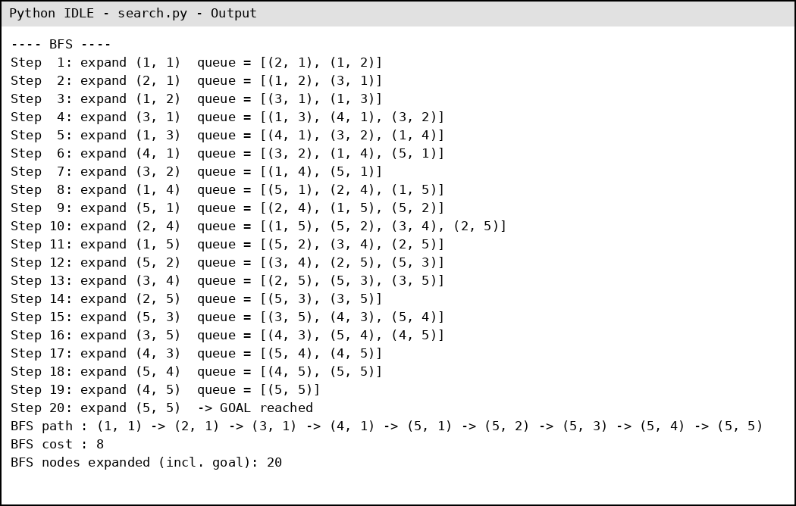

e. Depth-First Search (DFS)
Method: LIFO stack; neighbours are pushed so that Up is explored first, then Down, Left, Right (i.e. pushed in reverse order); explored states are not revisited; goal test applied when a node is popped.
Initial stack: [(1,1)]
Step | Node popped | Children pushed (in push order) | Stack (bottom → TOP) after step
1 | (1,1) | (2,1), (1,2) | (1,2), (2,1)
2 | (2,1) | (3,1) | (1,2), (3,1)
3 | (3,1) | (4,1), (3,2) | (1,2), (3,2), (4,1)
4 | (4,1) | (5,1) | (1,2), (3,2), (5,1)
5 | (5,1) | (5,2) | (1,2), (3,2), (5,2)
6 | (5,2) | (5,3) | (1,2), (3,2), (5,3)
7 | (5,3) | (4,3), (5,4) | (1,2), (3,2), (5,4), (4,3)
8 | (4,3) | — | (1,2), (3,2), (5,4)
9 | (5,4) | (5,5) | (1,2), (3,2), (5,5)
10 | (5,5) | GOAL reached | —

Note: at step 8, (4,3) is a dead end (its neighbours (3,3), (4,2), (4,4) are blocked and (5,3) is already explored), so DFS backtracks to (5,4). Nodes (1,2) and (3,2) remain unexplored on the stack.
Final path: (1,1) → (2,1) → (3,1) → (4,1) → (5,1) → (5,2) → (5,3) → (5,4) → (5,5)
Total path cost = 8. Nodes expanded before the goal: 9.
Remark: DFS does not guarantee the shortest path. With a different action order (e.g. Right first) it could return a longer route, such as one that wanders through the upper-right region before reaching (5,5).
Python implementation of DFS:
def dfs(start, goal):
stack = [start]
parent = {start: None}
explored = set()
step = 0
print("---- DFS ----")
while stack:
node = stack.pop()
if node in explored:
continue
step += 1
if node == goal:
print(f"Step {step:2d}: expand {node} -> GOAL reached")
return get_path(parent, node), step
explored.add(node)
for child in reversed(successors(node)): # Up is explored first
if child not in explored and child not in stack:
parent[child] = node
stack.append(child)
print(f"Step {step:2d}: expand {node} stack = {stack}")
return None, step

path, expanded = dfs(START, GOAL)
print(f"DFS path : {' -> '.join(map(str, path))}")
print(f"DFS cost : {len(path) - 1}")
print(f"DFS nodes expanded (incl. goal): {expanded}")
Output (Python IDE):
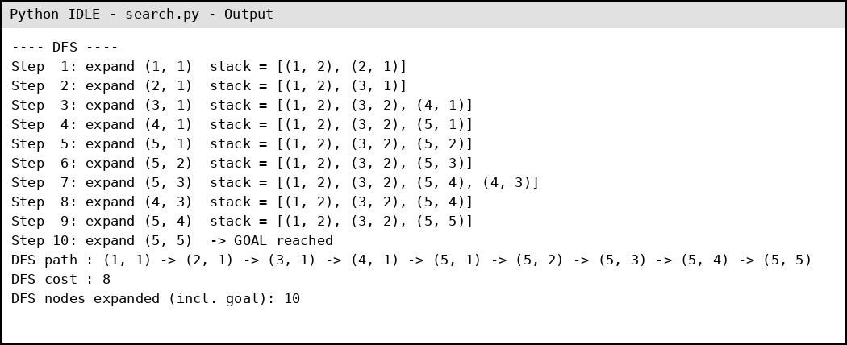

f. Comparison of BFS and DFS
Criterion | BFS | DFS
Completeness | Complete – finite grid (b ≤ 4), shallowest goal at depth d = 8, so it will always find a solution. | Complete here only because the grid is finite and an explored set avoids loops; without it, DFS can loop forever.
Optimality | Optimal – all step costs are equal (1), so the first path found is the cheapest (cost 8). | Not optimal in general – it returns the first path found, which may be longer. (It happened to find cost 8 here with the U-D-L-R ordering.)
Time complexity | O(b^d) = O(4^8) worst case; here 19 nodes expanded before the goal. | O(b^m), m = maximum depth (≤ 20 free cells); here only 9 nodes expanded before the goal.
Space complexity | O(b^d) – keeps the whole frontier in memory (max queue size 4 here). | O(b·m) – stores only the current path and siblings (max stack size 4 here).

Conclusion: BFS is more suitable for this warehouse delivery problem. The grid is tiny (20 free cells), so BFS's higher memory use is negligible, while its guarantee of the lowest-cost path is valuable because every move costs time and battery. DFS used less memory and expanded fewer nodes (9 vs 19), but its result depends on the action order and it does not guarantee the shortest route in general. Therefore BFS gives the optimal delivery path of cost 8 reliably.

